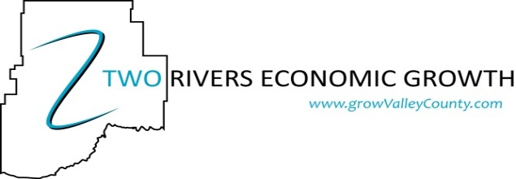
Contact Two Rivers Growth  Telephone 406.263.4769  Email trg2@nemont.net  Website www.growvalleycounty.com | FOR IMMEDIATE RELEASE  September 14, 2017

Glasgow completes Branding project
Glasgow, MT September 12, 2017 – Glasgow’s Branding Project by the City of Glasgow and Two Rivers Economic Growth is complete!
Two Rivers Economic Growth and the City of Glasgow recently completed the Glasgow Brand. This was done through cooperation with individuals representing Glasgow Area Chamber of Commerce, Glasgow Tourism Business Improvement District, Glasgow Schools, Glasgow Police Department, Frances Mahon Deaconess Hospital, Valley County Commissioners and several local business owners. The Glasgow Downtown Association successfully initiated this process and will be integral in utilizing this brand in the development and revitalization of downtown Glasgow.
Funding through the Montana Main Street Program made it possible to develop a City Growth Plan (2013) and a Downtown Master Plan (2015). Both of these documents identify the immediate need for a city-wide Brand. Two Rivers and the City of Glasgow applied to Montana Main Street once again for funding and hired the Wendt Agency of Great Falls to develop the Glasgow Brand based upon this direction.
A successful brand turns a location into a destination by building a name that makes a lasting impact on the public’s perceptions. Its aim is to turn a city into a place where people want to live, work and visit. A strong identity is vital in vying with other places for attention in tourism and business or revitalization initiatives. Through this process a logo and a tagline have been adopted to represent our area. Key assets and community values were identified and a positioning statement was formed:
“Proudly named after a town in Scotland, Glasgow is a vibrant hub in northeast Montana where life is lived at the pace you choose. Rooted in appreciation for tranquility, freedom, and tradition, life is just simpler here. Integrity and generosity are the backbone of our community, which is why our people go the extra mile for their neighbors and welcome visitors with a friendly smile and genuine northeastern Montana hospitality. Glasgow offers a blend of local retailers, quaint boutiques, fun family attractions, tasty coffee shops, eateries, and a brewery – all surrounded by sweeping landscapes and recreational opportunities under dramatically endless skies. With our wide open spaces, there is plenty of room to explore outdoor adventure and natures wonders without the crowds.”

From this positioning statement our brand promise was born: “In Glasgow, you will discover a new perspective on life and awaken your sense of peace, place and pride.” This promise then translated into our new tagline: “More of What Matters” and is part of our city logo. Glasgow’s new logo represents a strong agriculture industry, the Milk and Missouri Rivers, our dramatic sunrise and sunsets and an active, vibrant and progressive community. All of the colors within the image are also represented in the plaid pole banners throughout town and can be used in unison so that our Scottish heritage and pride continues to shine though.
Now that our brand is complete and a new grant cycle is open with Montana Main Street, Two Rivers and the City of Glasgow have taken the next step in applying to develop a Wayfinding Plan that will help pedestrians and vehicles navigate our city and identify key areas within the community to encourage patronage and vitality of space. We plan on beginning signage projects in May 2018 as a shovel-to-the-ground approach by getting to work as soon as the planning phase is complete to achieve visible results as soon as possible.
Two Rivers could not accomplish all that it has without the support and collaboration with the City of Glasgow and our membership. We truly value all of the hard work and input that has gone into the decision-making process and we are proud to represent our new brand. This will sharpen marketing efforts while reaching an identified target audience. As stewards of the Glasgow Brand it is important to maintain the integrity of the positioning statement and brand promise. Involved entities have agreed that as a community we will strive to deliver what visitors and residents value and maximize efforts by continuing to speak with one unified voice.
We encourage local businesses and organizations to utilize this brand in recruitment efforts and in promoting Glasgow as your chosen place to live, work & play. Please contact the Two Rivers office with questions or for logo images to place on your website or in publications by calling 406-263-GROW (4769) or email trg2@nemont.net. If you have not been to Glasgow, we encourage you to visit and see all that the seat of Valley County has to offer!

