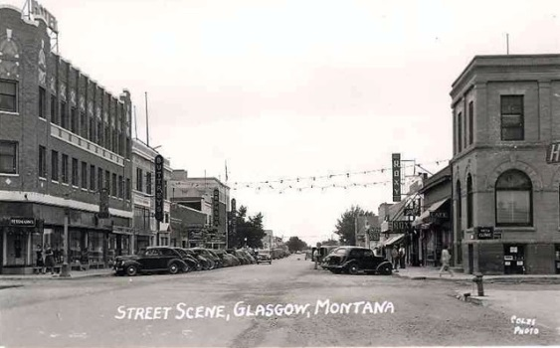

Valley County
Storefront Beautification
2020 Guidelines & Application

Two Rivers Economic Growth announces the “Storefront Beautification Grant Program!” The purpose of this program is to improve the street-side appeal of Valley County businesses. This encourages visitors to stop and shop while fostering continued growth and increased patronage in the local community.
This is a 50/50 matching grant opportunity in which applicants may apply for up to $1,000 in Two Rivers Economic Growth matching funds for storefront improvements. This may include signage, windows, paint, lighting, awnings, sidewalk improvements, landscaping, or a variety of other upgrades.
The Storefront Beautification Grant is a competitive grant with limited funding for businesses that are members of Two Rivers. If you are not a current member, please e-mail trg2@nemont.net for information on joining. Applicants will be scored by a collaborative committee with representatives from Two Rivers, TBID, City of Glasgow, Glasgow Chamber, and Glasgow Downtown Association.
Should your project be chosen for funding, the project must be completed within one year of the date on your award notification letter. An extension may be granted upon request.
All projects must meet State or City/Town zoning regulations. All required building permits must be in place before commencement of the project.
The following requirements must be met to release funding upon project completion:
- Provide both before and after photos of improvements.
- Provide copies of paid receipts/invoices that grant funds will be used to reimburse.
- Provide starting and completion date of project.
Two Rivers Economic Growth retains the right to question, alter, or reject any claim deemed inflated or unreasonable. The submitted application implies acceptance of these requirements and failure to provide required materials upon project completion will nullify this contract and disallow dispersal of grant funds. Two Rivers also retains the right to publish a Public Service Announcement when grant funds are awarded and at the project’s completion

Grant deadline is June 12, 2020. Awards will be announced by June 26, 2020

Name of Business:

Type of Business:

Physical Location:

Mailing Address:

Contact Name:

Contact Telephone #: Contact e-mail address:

Are there any local or state permits required for the proposed beautification project? € Yes € No
Have you applied for and received the necessary permits for your project?
€ Yes € No
Have you received the property owner’s permission if necessary?
€ Yes € No
Enclose a photo of the project area prior to work being done. Can be e-mailed to trg2@nemont.net
Proposed Project Start Date:
Description of Project:
How do you feel this project will benefit the community:
How will you measure the success of this project:
Amount Requested: $ Total Project Cost: $

Project Sources and Uses of Funds
Source of Funds: | Amount | Use of Funds: | Amount
Total Source of Funds: | $ | Total Use of Funds: | $
Authorizing Statement:
I hereby declare that the information included in and all attachments to this application are true, complete and accurate to the best of my knowledge. I further declare that, on behalf of ___________________________________________ (Business), I am legally authorized to enter into an agreement with Two Rivers Economic Growth if this grant is awarded. I further declare that if a grant is awarded, the grant will be used to fund the beautification project described above.

I understand that no grant funds will be released until the requirements for release of funding listed on the guidelines are met.

Signature: Date:

Return completed applications to:

Two Rivers Economic Growth
Attn: Keegan Morehouse
54147 Hwy 2 Suite 2
Glasgow, MT 59230

Or e-mail to trg2@nemont.net

